Results

Median filtering vs weighted averaging

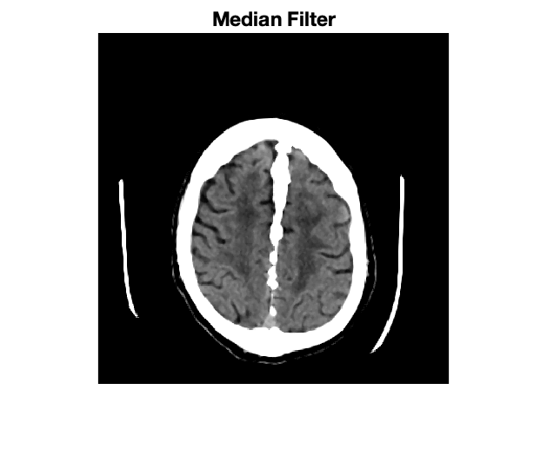

Figure 1. CT Brain Image after Median Filtering

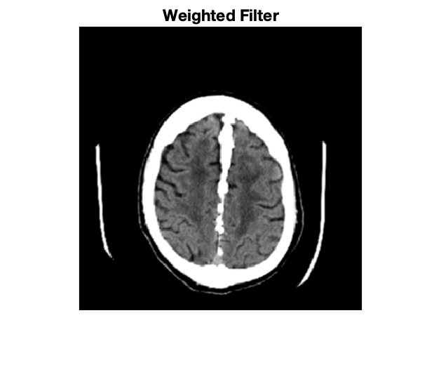

Figure 2. CT Brain Image after Weighted Averaging

Image Enhancement Methods

Histogram Equalization

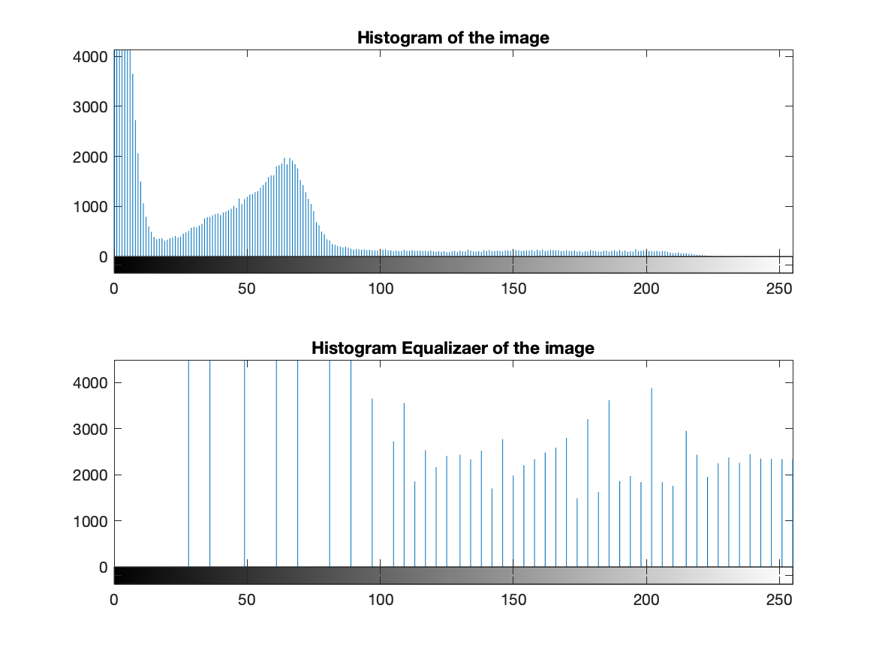

Figure 3. MR Brain Image with Histogram Equalization

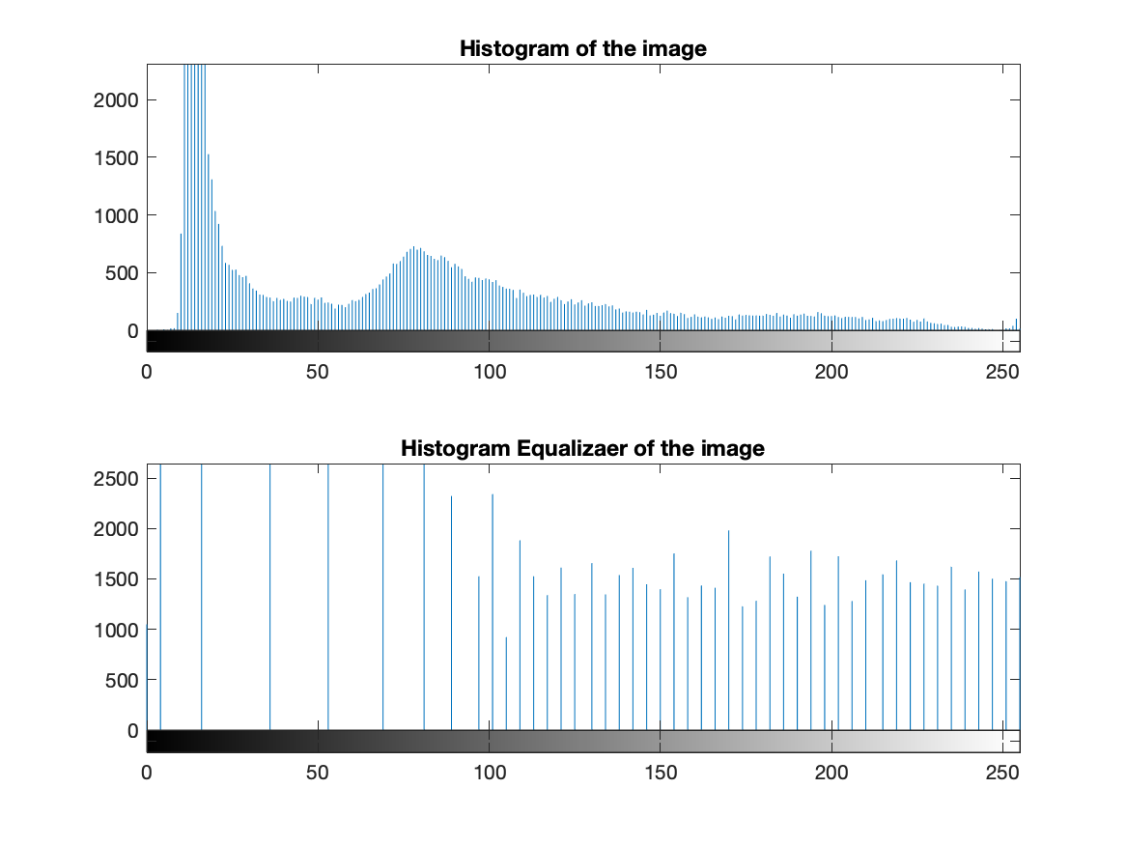

Figure 4. X-Ray Mammogram with Histogram Equalization

Sobel Gradient Mask

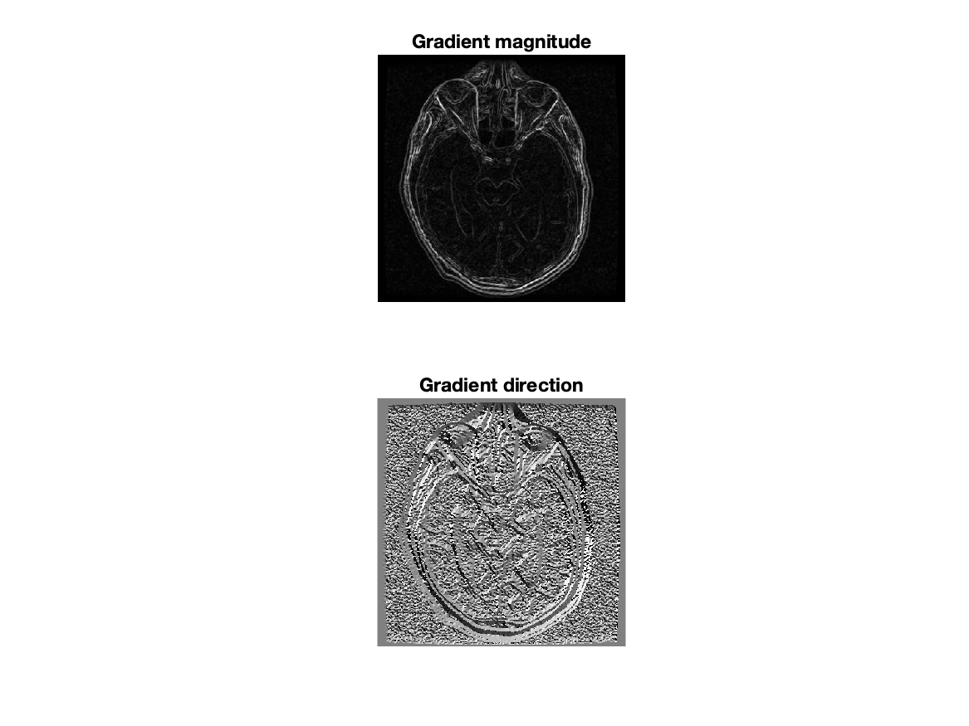

Figure 5. MR Brain Image with Sobel Gradient Mask

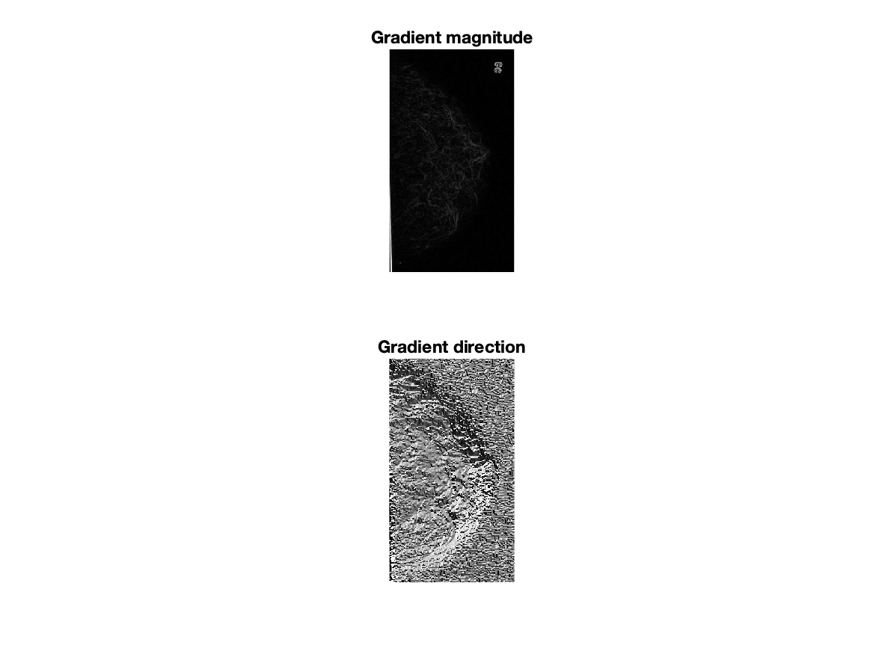

Figure 6. X-Ray Mammogram with Sobel Gradient Mask

Laplacian Gradient Mask

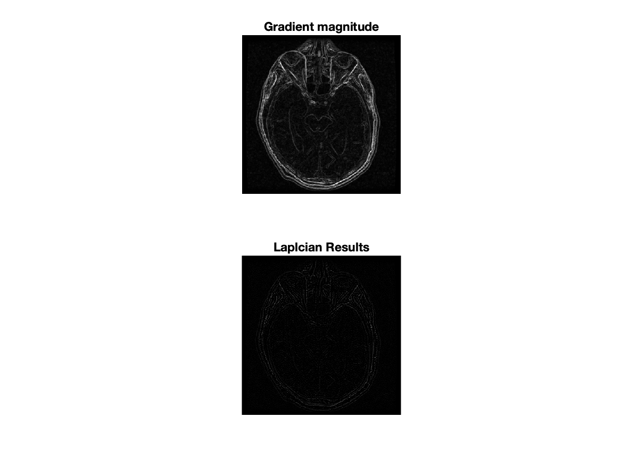

Figure 7. MR Brain Image with Laplacian Gradient Mask

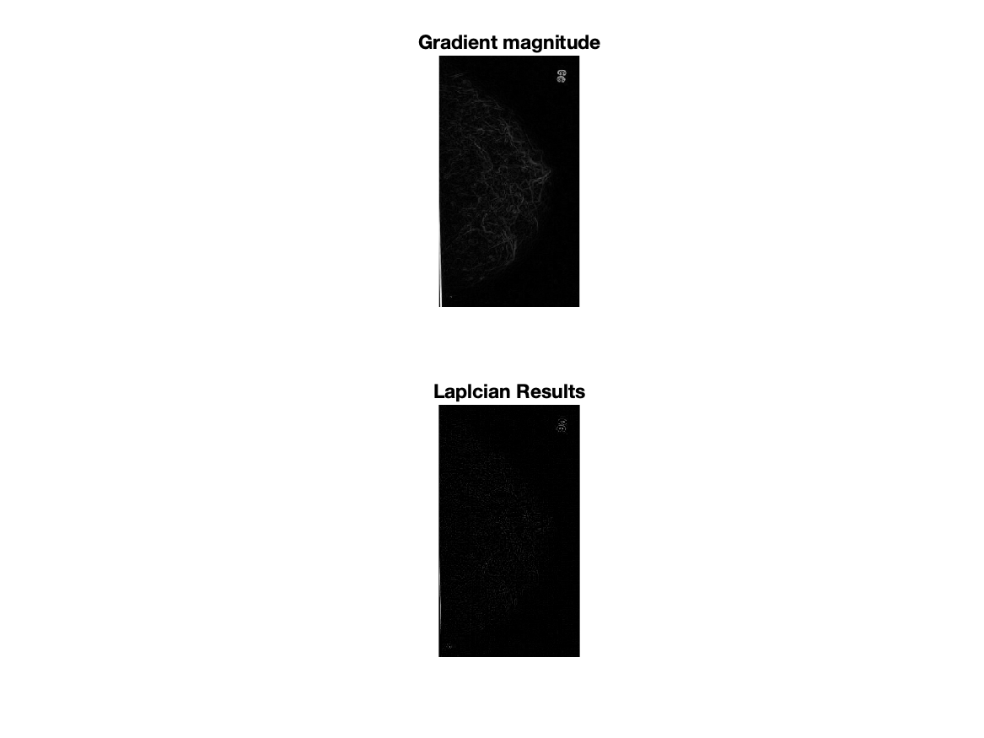

Figure 8. X-Ray Mammogram with Laplacian Gradient Mask

Local Histogram Equalization

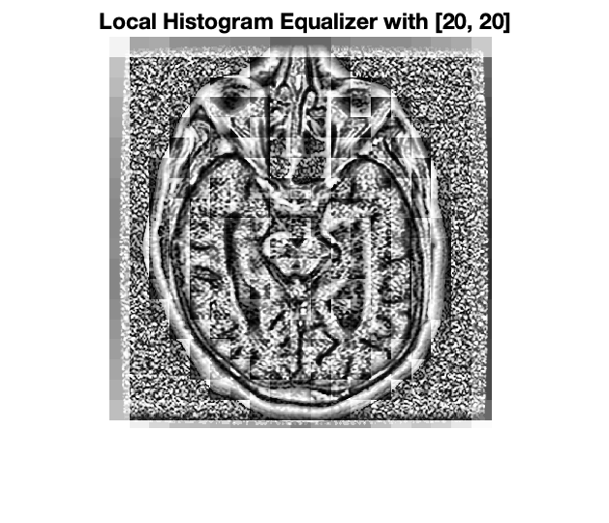

Figure 9. MR Brain Image with Local Histogram Equalization

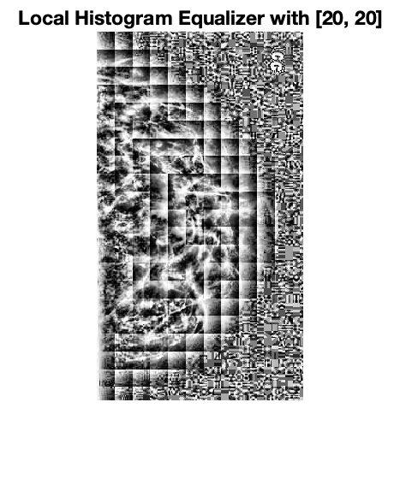

Figure 10. X-Ray Mammogram with Local Histogram Equalization

Gaussian High-pass Filtering

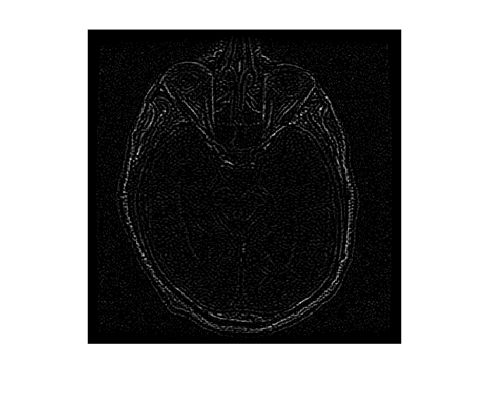

Figure 11. MR Brain Image with Gaussian High-Pass Filtering



Figure 12. X-Ray Mammogram with Gaussian High-Pass Filtering